Patent Description for “Robotics Controller for Intelligent Agents”

DO NOT INCLUDE ANY INFORMATION THAT IS NOT REQUIRED TO IMPLEMENT

High Level System Components:

Robot Control System Messenger:
Communication messaging interface/API between the Robot Hardware Controller and the Robotic Controller.

Instruction Manager:
A source for Instruction Object Lookups by Hardware ID, that includes Instruction Object, Message to Instruction Converters, Instruction to Message Converter classes, associated API documentation and checkin/checkout of those Objects from Object Pools. Hardware IDs
that are unregistered to a Instruction items are also available here.

Sensor Processor Manager (Optional):
Sensor Processors process incoming message data from the Robot Control System Messenger.
The following are examples of tasks that sensor processors might perform:
- Convert a proprietary message to an RMDMIA compatible data type or message.
- Add message to a message queue for RMDMIA processing
- Incoming Data Proxy for logging messages.
- Incoming Data Proxy for forwarding messaging to another location.

Movement Processor Manager (Optional):
Movement Processor implements algorithmic movement control for movement
calibration and movement based event launching. Algorithms built into movement
processors analyze, and if necessary trigger an event, or modify Instruction Object data.

Autonomous Object Generator Output Components:
Instruction Object (A schema defined object)
Instruction Object Pool (An array of the schema defined reusable Instruction Objects)
Instruction Input Handler Object (Converts source schema defined messages into schema defined Instruction Objects)
Instruction Output Handler Object (Converts Schema defined Instruction Objects into message format of target Object, System, Connection)
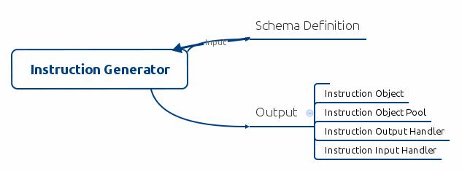

System Use Cases (figure out a better header later on):
Manual Override of Autonomous Control through Movement Processor Manager
Autonomous Reflex Control through Movement Processor Manager
Generate Instruction Object Tasks:

Patent on the RCSM? Or the System that integrates RCSM?:
An RCSM Plugin implementation
Note: Proof of Concept uses ROS RCSM Plugin implementation.

RMDMIA supports multiple plugins to be registered, and run at the same time.

ControllerManager Loads RMDMIA Components in the following order:

- RCSMManager
- InstructionManager
- InstructionManagerHardwareRegistry
- PerceptionEngine
- SensorProcessorManager
- SensorProcessorRegistry (contains the SensorProcessor[], and InstructionInputHandler associated with the SensorProcessor Instruction type (if applicable)). SensorProcessor may have a registered InstructionHandler, based on Hardware ID.
- GestureManager
- MovementProcessorManager
- MovementProcessorRegistry (contains the MovementProcessor[], and InstructionOutputHandler associated with the MovementProcessor Instruction type (if applicable)). MovementProcessor may have a registered InstructionHandler, based on Hardware ID.
- DecisionManager
- MissionManager
- TaskManager

Startup & Discovery Details:
The Instruction Manager manages registered instructions. The Instruction manager contains a hardware registry, that is a system lookup for hardware ids, and associated instruction.

Instructions are schema defined messages sent from connections through the RCSM plugin typically to/from the robot hardware controller.

Instructions make it possible for all messages to processed in a single language that can be recognized by the Robot Control System, and instructions can be generated automatically, and used by the Robot Control System instantaneously following their generation via a Schema Definition to a set of Objects that includes Instruction Objects, Instruction Input Handlers, Instruction Output Handlers, and Instruction Object Pools, each managed with an Instruction Definition Object.

Startup:
At startup zero to many RCSM Plugins/Providers are initialized.
The Instruction Manager will be initialized following RCSM Plugins/Providers initialization.
- The Instruction Manager initialization routine:
- Instruction Manager configuration is loaded.
- Instruction Manager generates a Schema Definition lookup table [[schema definition id,schema definition],...].
- Instruction Manager generates an Instruction Object lookup table [[instruction id, instruction],...].
- Instruction Manager initializes/generates the hardware registry lookup table [[hardware id, Instruction Definition Configuration],...]. Hardware ids are unique to each RCSM Plugin Sensor/Movement connection. Each sensor/movement connection incoming/outgoing data is defined by a schema definition (structured messages). Different RCSM Plugins will likely use different Schema formats, therefore, each RCSM Provider implementation contains an Instruction Builder implementation that is called by the Instruction Manager if an Instruction Object does not exist for an associated hardware id/instruction definition.
- At this point if an instruction definition gets a call to retrieve an Instruction, Instruction Input Handler, Instruction Output Handler, or Instruction Object Pool, and an Instruction Object does not exist an instruction object will be generated, and registered with the Instruction Manager. If the Instruction Object(s) exist, but are not registered they will be registered. If a schema does not exist, it may generated and passed into the associated RCSM Instruction Builder implementation.
- Optionally, Instruction Object(s) can be generated at startup for every available RCSM Plugin schema definition if schemas are available at that time, however, this may be over excessive, and not optimal.
- Schema definitions may be available in a central local storage, or they may be available through network storage, or a network based schema definition lookup service

Post InstructionManager, and RCSM Provider loading (Optional: Startup of Movement Processor Manager, and Sensor Processor Manager):
Movement Processor Manager Initialization:
- Movement Processor Manager configuration is loaded.
- Each Hardware id contains an array of associated Movement Processors. Each Movement Processors are executed ordered iteratively, each taking an associated Instruction Object, and performing updates to the Instruction Object, or performing a procedure(s) from the Movement Processor, before being sent to the next Movement Processor, until each enabled Movement Processor has been executed.
Implementors of Instruction Output Handlers can make those Instruction Output Handlers Movement Processors. Instruction Output Handler Movement Processors will convert the Instruction Object to the outgoing message format as bytes, and will send the outgoing message through the RCSM Provider, or pass the native message to an Object, or move to the next Movement Processor if one is specified, or execute a registered instruction handler.
Sensor Processor Manager Initialization:
- Sensor Processor Manager configuration is loaded.
- Each Hardware id contains an array of associated Sensor Processors. Sensor Processors are executed ordered iteratively, each taking an associated Native message, and performing routines to the native message, or performing a procedure(s) from the Sensor Processor, before being sent to the next Sensor Processor, until each enabled Sensor Processor has been executed.
Implementors of Instruction Input Handlers can make those Instruction Input Handlers Sensor Processors. Instruction Input Handler Sensor Processors will convert the native incoming message into an Instruction Object, and will then execute a registered Instruction Handler, that will process that Instruction, or send that Instruction to its next location in the system.

- Next Step...

Instruction Object: Object Pool Element Identifier variable (Instruction Object variable containing the Object Pool Element Index):
Instruction Objects may define an element identifier for identifying the Instruction Object Pool Instruction Object index.

Instruction Object: Hardware Identifier variable:
The instruction may define a Hardware Identifier variable. The Instruction Manager can use the Hardware Identifier variable to lookup the associated Instruction Definition, Instruction Object, Instruction Object Pool, Instruction Input Handler, Instruction Output Handler, RCSM Provider, Sensor Manager Processors, and Movement Processors.

Instruction Object: In Use variable:
The instruction may define an In Use variable. The Instruction Object Pool may use the in use variable to determine if an Instruction Object is available to be checked out, or if the Object is checked out (In Use). Other options for the In Use variable include multi threaded processing, when the Instruction Object is currently being processed by a thread, and the following call was to checkin, the Instruction Object. The In Use variable could be used to wait to checkin Object until the Object variable is no longer In Use, or Timeout, and check the Instruction Object back in, if In Use variable does not change. The In Use variable may also be used in multi-threaded Instruction processing where an Instruction must contain a particular In Use variable value.

Instruction Object: length operation:
Converting Fixed Length and Variable Length Schema Definition types for Instruction Object conversion to Native messages via the Instruction Output Handler Objects.

Fixed Length Schema Definitions (Schema Definitions that contain only fixed length variables that a message byte array length (sum of schema definition variables) can be calculated and a numeric length (hard coded)).

Variable Length Schema Definitions (Schema Definitions that have a length that cannot be known at the time the code is generated due to 1 or more variables that are variable length).
Dynamic Options such as Byte Buffers work in these scenarios, but typically are less efficient than a primitive byte array. Dynamic Length Schema Definitions (Schema Definitions that have a length that cannot be known at the time the code is generated due to 1 or more variables that are variable length). This gets tricky when a variable can contain arrays, or custom variable types that contain nested variable length type definitions. An Instruction could be introspected to determine structure and length via the Instruction Output Handler to define, and instantiate length, it was decided to add a length function to each Instruction Object, that is coded by the code generator to output the Instruction byte array length when it is processed by the Instruction Output Handler. That function may be utilized to determine the byte array length in the Instruction Output Handler to set the byte array length on variable length schema definition Instruction Objects.

Instruction Object Pool:
The intent of the Instruction Object Pool is to lower latency of producing Instruction Objects, by reusing Instruction Objects of the Instruction Schema type, rather than redefining, instantiating, or generating new Objects. An Instruction Object Pool, is not required for Autonomous Object Generation, it is the lowest latency solution in some implementations, therefore, this is an optional implementation path of this system that can decrease latency, therefore increasing the number of Instructions Object transactions that can be processed in time.

Instruction Object Pool: Hardware Identifier variable:
The Instruction Object Pool Hardware Identifier variable. The Instruction Object Pool Hardware Identifier will match Instruction Objects available in that pool.

Instruction Object Pool: Check In operation:
The Instruction Object Pool Check In operation will return the Instruction Object back to Instruction Object Pool for being available to be checked out.

Instruction Object Pool: Check Out operation:
The Instruction Object Pool Check Out operation will obtain an Instruction Object from the Instruction Object Pool, that will not be avaiable for check out until that Object is Checked Back in.

Instruction Input Handler: The details of when the Instruction Handler is called, and which methods call it after byte array to Instruction conversion need to be straightened out for patent specification clarity ASAP.

Instruction Input Handler: Transform operation:
Input a received byte array, and output an Instruction Object with the message data represented as an Instruction Object.

Instruction Input Handler: Register Instruction Handler operation:
Register an Instruction Handler, that will process, and/or send the Instruction to its next destination, when the Instruction Handler process operation is called. If an Instruction Handler is not registered with the Instruction Input Handler, and the Instruction process method is called Instruction will automatically be checked back into the Instruction's Instruction Object Pool (If an Object Pool is not associated with the Instruction, the Instruction value will be set to null).

Instruction Input Handler: Is Instruction Handler Registered operation:
Return a variable that communicates that the Instruction Handler is, or is not registered with the Instruction Input Handler.

Instruction Input Handler: Return the Instruction Handler operation:
Return the Registered Instruction Handler. Returns null if an Instruction Handler is not Registered.

Instruction Input Handler: Return the Instruction Object Pool operation:
Return the Instruction Object Pool associated with the Instruction Input Handler Hardware Identifier. Return null, if this operation is not implemented in the Instruction Input Handler, and/or if the hardware identifier associated Instruction is not provided by an Instruction Object Pool.

Instruction Input Handler with Sensor Processor support (Only necessary for Instruction Input Handlers that are adapted for Sensor Processor functionality): Process operation:
The process operation converts the Sensor Message Object into an Instruction, and if an Instruction Handler was registered with the Instruction Input Handler, the Instruction Handler process operation is called, and the Instruction Object is passed in as an input parameter. The Sensor Message is returned to the Sensor Processor Manager to be passed to the next Sensor Processor if one ahead of the current Sensor Processor.

Instruction Output Handler:

Instruction Output Handler: Transform operation:
Input a received Instruction, and output a byte array in the message format of the RCSM Provider.
Instruction Output Handler: Send operation:
Input a received Instruction, convert to a byte array in the message format of the RCSM Provider, send the message directly to the RCSM Provider, and check in the Instruction to the Instruction Object Pool (If the pool is not null), if pool is null set the Object to null. If the Is Recording operation, or the Is Recording operation's variable is true log the message before the Instruction is checked in, or set to null.

Instruction Output Handler with Movement Processor support: Process operation:
Input a received Instruction, convert to a byte array in the message format of the RCSM Provider, send the message directly to the RCSM Provider, and check in the Instruction to the Instruction Object Pool (If the pool is not null), if pool is null set the Object to null. If the Is Recording operation, or the Is Recording operation's variable is true log the message before the Instruction is checked in, or set to null.

Instruction Output Handler: Process Instruction Handler operation:
If an Instruction Handler is registered for the Instruction Output Handler, calls the Instruction Handler process operation.

Instruction Output Handler: Register Instruction Handler operation:
Register an Instruction Handler, that will process, and/or send the Instruction to its next destination, when the Instruction Handler process operation is called. If an Instruction Handler is not registered with the Instruction Output Handler, and the Instruction process method is called Instruction will automatically be checked back into the Instruction's Instruction Object Pool (If an Object Pool is not associated with the Instruction, the Instruction value will be set to null).

Instruction Output Handler: Is Instruction Handler Registered operation:
Return a variable that communicates that the Instruction Handler is, or is not registered with the Instruction Output Handler.

Instruction Output Handler: Return the Instruction Handler operation:
Return the Registered Instruction Handler. Returns null if an Instruction Handler is not Registered.

Instruction Output Handler: Return the Instruction Object Pool operation:
Return the Instruction Object Pool associated with the Instruction Output Handler Hardware Identifier. Return null, if this operation is not implemented in the Instruction Output Handler, and/or if the hardware identifier associated Instruction is not provided by an Instruction Object Pool.

Instruction Output Handler (non-core feature enhancement for message tracing & logging): Is Recording operation:
Return a variable value that indicates if the Instruction Output Handler is Recording outgoing messages, or if the Instruction Output Handler is not Recording outgoing messages. This operation, or the operation's read variable may be used by the send, and process Instruction Output Handler operations to determine if the message should be recorded.

Instruction Output Handler (non-core feature enhancement for message tracing & logging): Set is Recording operation:
Set a variable value that indicates if the Instruction Output Handler is Recording outgoing messages, or if the Instruction Output Handler is not Recording outgoing messages.

Instruction Handler:
Instruction Handler: Process operation:
A Instruction Handler process operation to process the Instruction input. May be implemented for forwarding an instruction to next destination. Instruction Handler support is implemented in both Instruction Input Handlers, and Instruction Output Handlers. Instruction Handler initial design intent was supporting Instruction Input Handlers implemented with Sensor Processors, it was later determined Instruction Handler's were a useful mechanism in general use instruction handling for processing, forwarding, directing instructions in machine generated code, custom coding implementations, and artificial intelligence processing, thus, the process handler operation in the Instruction Output Handler, and the implementation of the Instruction Handler in the process operation of the Instruction Input Handler.

Sensor Processor Manager:

Sensor Processor Manager: Process single Sensor Message operation:
Process the Sensor Message and return the sensor message.

Process operation flow steps:
- Input a Sensor Message into the process operation.
- If Sensor Message is null, return null.
Actual mechanism for obtaining the movement processors may vary
- If Sensor Message is not null, Get an array of the Sensor Processors with the same hardware identifier as the Sensor Message's hardware identifier, and iterate through each Sensor Processor.
- If the hardware identifier of the Sensor Processor is not set to on hold, and the sensor identifier is not on hold (hold status functionality is optional).
- Call Sensor Processor Pool checkout(loop count) operation to obtain a Sensor Processor, and assign the Sensor Processor to a variable.
- Call the Sensor Processor variable just checked out, process method with the Sensor Message as input parameter.
- After the Sensor Message is returned: call the Sensor Processor Pool check in operation with the Sensor Processor's Cache Pool Identifier variable as the input parameter.
- iterate loop count, and continue loop while the hardware identifier array length is greater than the loop count.
- Else, iterate loop count, and continue loop while the hardware identifier array length is greater than the loop count.
- Return the Sensor Message.

Sensor Processor Manager: Process zero to many Sensor Message operation:
Process the Sensor Message array and return the processed Sensor Message array.

Process operation flow steps:
- Input a Sensor Message array input into the process operation.
- If Sensor Message array is null, return null.
Actual mechanism for obtaining the movement processors may vary
- Iterate through each sensor message:
- If Sensor Message is not null, Get an array of the Sensor Processors with the same hardware identifier as the Sensor Message's hardware identifier, and iterate through each Sensor Processor.
- If the hardware identifier of the Sensor Processor is not set to on hold, and the sensor identifier is not on hold (hold status functionality is optional).
- Call Sensor Processor Pool checkout(loop count) operation to obtain a Sensor Processor, and assign the Sensor Processor to a variable.
- Call the Sensor Processor variable just checked out, process method with the Sensor Message as input parameter.
- After the Sensor Message is returned: call the Sensor Processor Pool check in operation with the with the Sensor Processor's Cache Pool Identifier variable as the input parameter.
- iterate loop count, and continue loop while the hardware identifier array length is greater than the loop count.
- Else, iterate loop count, and continue loop while the hardware identifier array length is greater than the loop count.
- Return the Sensor Message array.

Sensor Processor Manager: Add Sensor Processor Factory by Hardware Identifier operation:
Add sensor processor by hardware id. This method inputs include hardware identifier, and a Sensor Processor Factory.

Note (Should this be moved to Hardware Identifier variable? Is this still valid in patent application for Instruction Manager? Is this relevant to the patent description? Might not be): Hardware IDs must be manually registered/defined, and can be virtual, logical, or physical hardware groupings (implementor specific).

Question: Is this feature still valid?
If a hardware ID was not pre-created the specified input will be created as a new hardware ID on the fly. A return value of -1 means an error occurred.

Sensor Processor Manager: Remove Sensor Processor by Hardware Identifier operation:
Remove the specified sensor processor by hardware identifier input.

Sensor Processor Manager: Remove Sensor Processor by Hardware Identifier/Sensor Processor Identifier operation:
Remove the specified sensor processor by hardware identifier input /sensor processor identifier input.

Sensor Processor Manager: Check out the Sensor Processor by Hardware Identifier/Sensor Processor Identifier operation:
Checks out the specified sensor processor by input Sensor Processor Identifier, and Hardware Identifier operation inputs.
All checked out sensor processors must be checked back in because they decrement the total pool count each check out. Returns null if an associated sensor processor is not registered.

Sensor Processor Manager: Check out the Sensor Processor by Sensor Processor Identifier operation:
Checks out the specified sensor processor by input Sensor Processor Identifier.
All checked out sensor processors must be checked back in because they decrement the total pool count each check out. Returns null if an associated sensor processor is not registered.

Sensor Processor Manager: Check in the Sensor Processor by Cache Pool Identifier operation:
Check in the Sensor Processor Object for recycling by Sensor Processor Cache Pool ID input parameter (This operation calls the Sensor Processor Pool Object Check In operation).

Sensor Processor Manager: Hold execution of all Sensor processors on specified Hardware Identifier operation:
Hold execution of all sensor processors on specified hardware identifier.

Note (Need to verify this is valid requirement, or leftover from research...): All registered sensor processors will be excluded from modifying sensor instructions on the specified hardware identifier until continue operation is called.

Sensor Processor Manager: Hold execution of the specified Sensor Processor for the specified Hardware Identifier/Sensor Processor Identifier operation:
Hold execution of the specified sensor processor identifier input for the specified hardware identifier input.

Note (Need to verify this is valid requirement, or leftover from research...): All registered sensor processors will be excluded from modifying sensor instructions on the specified hardware identifier until continue operation is called.

Sensor Processor Manager: Is on Hold operation for Hardware Identifier/Sensor Processor Identifier operation:
Return variable for is on hold, or is not on hold for Sensor Processor associated with Sensor Processor identifier input, and hardware identifier identifier input.

Sensor Processor Manager: Continue execution of all Sensor Processors on the specified Hardware Identifier operation:
Continue execution of all sensor processors on the specified Hardware Identifier input. If continue is called on an already functional not on hold sensor processor, the sensor processor will continue to operate normally.
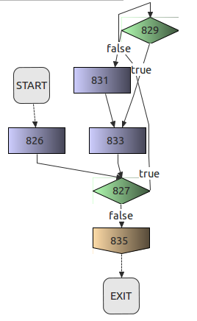

Sensor Processor Manager: Continue execution of the specified Sensor Processor for the specified Hardware Identifier/Sensor Processor Identifier operation:
Continue execution of the specified sensor processor identifier input on the specified Hardware Identifier input. If continue operation is called on an already functional not on hold sensor processor, the sensor processor will continue to operate normally.

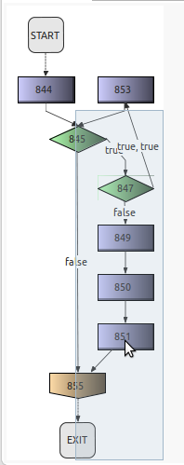

Sensor Processor Manager: Get Processing Sensor Processor Identifiers operation:
Return a list (int[][]) of processing sensor processors, the returned list excludes all onHold or registered but non-functional sensor processors. The returned list is an int[][] the format of each element as int[] where int[0]=hardwareID, int[1]=sensorProcessorID. return int[][] The structure of each element as int[] where int[0]=hardwareID, int[1]=sensorProcessorID.

Sensor Processor Manager: Get registered Sensor Processor Identifiers operation:
Return a list (int[][]) of registered sensor processors, in the format of each element as int[] where int[0]=hardwareID, int[1]=sensorProcessorID. Return int[][] The format of each element as int[] where int[0]=hardwareID, int[1]=sensorProcessorID.

Sensor Processor Manager: Get registered Sensor Processor Identifiers Status operation:
Return a list (int[][]) of registered sensor processors and isOnHoldStatus(), in the format of each element as int[] where int[0]=hardwareID, int[1]=sensorProcessorID, int[2]=boolean is on hold.
Return int[][] The format of each element as int[] where int[0]=hardwareID, int[1]=sensorProcessorID, int[2]=boolean is on hold.

Sensor Processor Pool: Description:
Instantiate the Sensor Processor Pool with Input variables of SensorProcessorFactory 0 to many Array, and Sensor Processor Pool Range Length number variable.
SENSOR_PROCESSOR_POOL_SIZE = sensorProcessorFactoryArray.length * sensorProcessorPoolRangeLength;
RANGE_LENGTH= sensorProcessorPoolRangeLength;
// initialize the poolRangeIterationArray
this.poolIterationCountArray = new int[SENSOR_PROCESSOR_POOL_SIZE];
this.availabilityArray = new boolean[SENSOR_PROCESSOR_POOL_SIZE];
this.sensorProcessorArray = new SensorProcessor[SENSOR_PROCESSOR_POOL_SIZE];
// Set the Factory Pool Range Count to Zero for the loop.
this.factoryPoolRangeCount = 0;
while(checkoutCount<sensorProcessorArray.length)
{
// Set the Factory Pool Loop Count
this.factoryPoolLoopCount=0;
while(factoryPoolLoopCount<RANGE_LENGTH)
{
// Core process
this.availabilityArray[checkoutCount]=true;
this.sensorProcessorArray[checkoutCount]=(SensorProcessor) sensorProcessorFactoryArray[factoryPoolRangeCount].newSensorProcessor();
this.sensorProcessorArray[checkoutCount].cid = checkoutCount;
// TODO: Strip this variable later on if it is not implemented one way or another.
this.sensorProcessorArray[checkoutCount].sid = factoryPoolRangeCount;
this.checkoutCount=checkoutCount + 1;
// End core process
// Increment Loop
this.factoryPoolLoopCount = factoryPoolLoopCount + 1;
}
// Append to factoryPoolRangeCount
this.factoryPoolRangeCount = factoryPoolRangeCount + 1;
}
this.checkoutCount = 0;

Sensor Processor Pool: Check In operation:
Checkin the SensorProcessor Object for recycling by Sensor Processor Cache Pool ID input parameter.
Java source code implementation:
public void checkin(final int cid)
{
this.sensorProcessorArray[cid].recycle();
availabilityArray[cid]=true;
}
Sensor Processor Pool: Check Out operation:
Checkout a SensorProcessor by sid. sid is the SensorProcessorFactory array index of the SensorProcessor being requested.
It is up to the implementor of this Object in code to make sure that the RANGE_LENGTH is sufficient for the number of threads that may execute the RANGE. Additionally, the loop only cycles till the end of the array, and if the oldest checked out Object has not yet been returned to the pool, null is returned, therefore it is advised if null is returned that the implementing code retry checkout again. If the quantity of RANGE Objects is sufficient an Object wil always be available.

Java Source Code implementation:
public SensorProcessor checkout(int sid)
{
// maximum range index = (sid * RANGE_LENGTH) + RANGE_LENGTH - 1;
this.maximumIndexRangePlusOne = (sid * RANGE_LENGTH) + RANGE_LENGTH;
// Set the current checkoutCount to the sid range last checked out.
// checkoutCount = (sid * RANGE_LENGTH) + poolIterationCountArray[sid];
// subtraction is less math then multiplication, so subtract RANGE_LENGTH from maximumIndexRangePlusOne
this.checkoutCount = (maximumIndexRangePlusOne - RANGE_LENGTH) + poolIterationCountArray[sid];
if(checkoutCount<maximumIndexRangePlusOne)
{
// While loop must test range length to ensure an infinite loop does not occur.
while(checkoutCount<maximumIndexRangePlusOne)
{
// If value is false, check out Object, and set value to true.
if(this.availabilityArray[checkoutCount])
{
this.availabilityArray[checkoutCount]=false;
// Set the next checkout range position.
this.poolIterationCountArray[sid]=(this.checkoutCount - (maximumIndexRangePlusOne - RANGE_LENGTH)) + 1;
return (SensorProcessor)sensorProcessorArray[checkoutCount];
}
this.checkoutCount = checkoutCount + 1;
}
return null;
}
else
{
// Reset poolIterationCountArray
poolIterationCountArray[sid]=0;
// Reset checkoutCount to 0 because it is out of index bounds.
this.checkoutCount = maximumIndexRangePlusOne - RANGE_LENGTH;
// While loop must test range length to ensure an infinite loop does not occur.
while(checkoutCount<maximumIndexRangePlusOne)
{
// If value is false, check out Object, and set value to true.
if(this.availabilityArray[checkoutCount])
{
this.availabilityArray[checkoutCount]=false;
// Set the next checkout range position.
this.poolIterationCountArray[sid]=(this.checkoutCount - (maximumIndexRangePlusOne - RANGE_LENGTH)) + 1;
return (SensorProcessor)sensorProcessorArray[checkoutCount];
}
this.checkoutCount = checkoutCount + 1;
}
return null;
}
}

Sensor Processor: Description:
Sensor Processors process incoming sensor messages.
The following are examples of tasks that sensor processors might perform:
- Convert a proprietary message to an Instruction.
- Process the message through an Instruction Input Handler.
- Incoming Data Proxy for logging messages.
- Incoming Data Proxy for forwarding messaging to another location.

Sensor Processor: Cache Pool Identifier variable:
Each Sensor Processor element will have a unique Cache Pool Identifier, that is the Sensor Processor Array element index.

Sensor Processor: Sensor Processor Identifier variable:
Each type of Sensor Processor may define a Sensor Processor Identifier. The Sensor Processor Identifier will apply to each Sensor Processor in a Sensor Processor Pool RANGE.

Sensor Processor: Hardware Identifier variable:
The Sensor Processor may define a Hardware Identifier variable. The Instruction Manager can use the Hardware Identifier variable to lookup the associated Instruction Definition, Instruction Object, Instruction Object Pool, Instruction Input Handler, Instruction Output Handler, RCSM Provider, Sensor Processor Manager Sensor Processors, and Movement Processor Manager Movement Processors.

Sensor Processor: Process operation:
Each sensor processor should implement a process operation to process a sensor message.

Sensor Processor: Recycle operation:
The recycle operation is called by the Sensor Processor Pool Check In operation to reset the Sensor Processor Object to its default variable settings for reuse.

Sensor Processor Message Logger Factory:
Applied to each Sensor Processor Hardware Identifier, the Message Logger Factory will write incoming Sensor Processor Manager messages to the Sensor Processor Message Logger of the associated Hardware Identifier. The Sensor Processor Message Logger Factory can be register immediately following an Instruction Input Handler to ensure the message is sent before the Sensor Processor Message Logger Factory, thereby eliminating the Sensor Processor Message Logger Factory as a source of latency, and bypassing a potential throughput hold up while Sensor Processor Message Logger Factory processes.

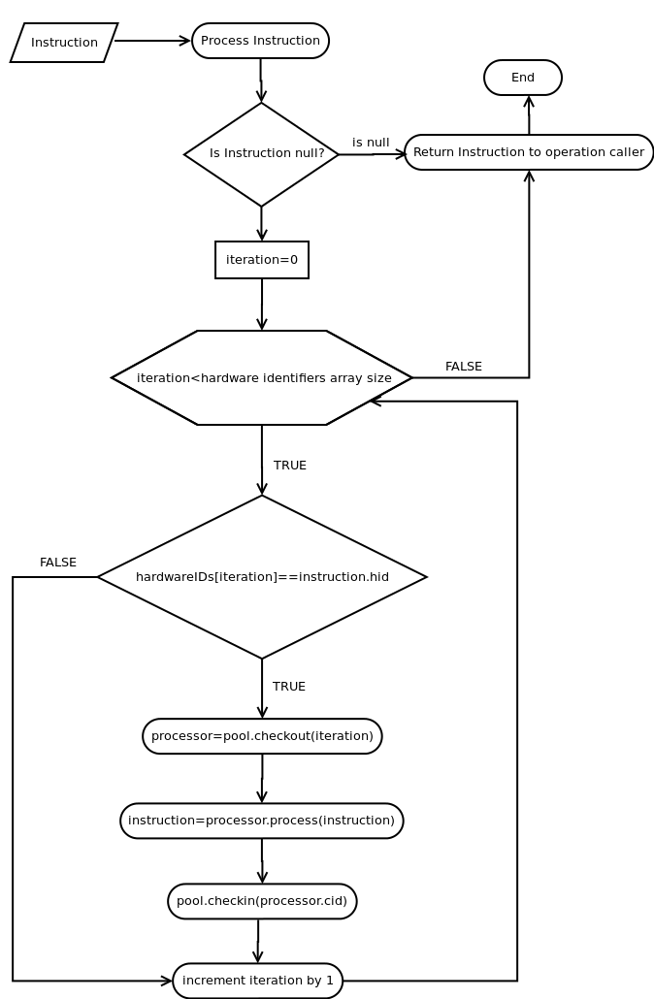
Movement Processor Manager: Description:
Movement Processor implements algorithmic movement control for movement
calibration and movement based event launching. Algorithms built into movement
processors are intended to increase/decrease numeric input parameters for
movement updates.

The Movement Processing Manager Object will support the following operations
to support managing movement processors:
- add operation
- remove operation
- hold operation
- continue operation
- start operation
- stop operation
- recycle operation

A movement processor interface must be defined for movement processor implementers to define processing rules for a test method to determine if the current registered processor will modify data, call a gesture (a Gesture Object contains timed hardware movement instructions by time interval. Each interval contains multiple hardware identifiers to be executed together.), or perform an action(s).

Movement Processor Manager: Process single Instruction operation:
Process the Instruction and return the processed instruction.

Process operation flow steps:
- Input a Instruction input into the process operation.
- If Instruction is null, return null.
Actual mechanism for obtaining the movement processors may vary
- If Instruction is not null, Get an array of the Movement Processors with the same hardware identifier as the Instruction's hardware identifier, and iterate through each Movement Processor.
- If the hardware identifier of the Movement Processor is not set to on hold, and the movement identifier is not on hold (hold status functionality is optional).
- Call Movement Processor Pool checkout(loop count) operation to obtain a Movement Processor, and assign the Movement Processor to a variable.
- Call the Movement Processor variable just checked out, process method with the Instruction as input parameter.
- After the Instruction is returned: call the Movement Processor Pool check in operation with the with the Movement Processor's Cache Pool Identifier variable as the input parameter.
- iterate loop count, and continue loop while the hardware identifier array length is greater than the loop count.
- Else, iterate loop count, and continue loop while the hardware identifier array length is greater than the loop count.
- Return the Instruction.

Movement Processor Manager: Process zero to many Instruction operations of zero to many Hardware Identifiers:
Process the Instruction array and return the processed instruction array.

Process operation flow steps:
- Input a Instruction Array input into the process operation.
- If Instruction array is null, return null.
Actual mechanism for obtaining the movement processors may vary
- Iterate through each instruction:
- If Instruction is not null, Get an array of the Movement Processors with the same hardware identifier as the Instruction's hardware identifier, and iterate through each Movement Processor.
- If the hardware identifier of the Movement Processor is not set to on hold, and the movement identifier is not on hold (hold status functionality is optional).
- Call Movement Processor Pool checkout(loop count) operation to obtain a Movement Processor, and assign the Movement Processor to a variable.
- Call the Movement Processor variable just checked out, process method with the Instruction as input parameter.
- After the Instruction is returned: call the Movement Processor Pool check in operation with the with the Movement Processor's Cache Pool Identifier variable as the input parameter.
- iterate loop count, and continue loop while the hardware identifier array length is greater than the loop count.
- Else, iterate loop count, and continue loop while the hardware identifier array length is greater than the loop count.
- Return the Instruction array.

Movement Processor Manager Process operation Flow Chart:

Movement Processor Manager Process operation Flow Diagram: Dependencies:
- Movement Processor Pool checkin operation Flow diagram
- Movement Processor Pool checkout operation Flow diagram
- Movement Processor process operation Flow diagram.

Movement Processor Manager: Add Movement Processor by Hardware Identifier operation:
Add movement processor by hardware id. This method inputs include hardware identifier, and a Movement Processor Factory.

Note (Should this be moved to Hardware Identifier variable? Is this still valid in patent application for Instruction Manager? Is this relevant to the patent description? Might not be): Hardware IDs must be manually registered/defined, and can be virtual, logical, or physical hardware groupings (implementor specific).

Question: Is this feature still valid?
If a hardware ID was not pre-created the specified input will be created as a new hardware ID on the fly. A return value of -1 means an error occurred.

Movement Processor Manager: Remove Movement Processor by Hardware Identifier operation:
Remove the specified movement processor by hardware identifier input.

Movement Processor Manager: Remove Movement Processor by Hardware Identifier/Movement Processor Identifier operation:
Remove the specified movement processor by hardware identifier input /movement processor identifier input.

Movement Processor Manager: Check out the Movement Processor by Movement Processor Identifier operation:
Checks out the specified movement processor by input Movement Processor Identifier.
All checked out movement processors must be checked back in because they decrement the total pool count each check out. Returns null if an associated movement processor is not registered.

Movement Processor Manager: Check out the Movement Processor by Movement Processor Identifier, and Hardware Identifier inputs operation:
Checks out the specified movement processor by input Movement Processor Identifier, and Hardware Identifier operation inputs.
All checked out movement processors must be checked back in because they decrement the total pool count each check out. Returns null if an associated movement processor is not registered.

Movement Processor Manager: Check in the Movement Processor by Cache Pool Identifier operation:
Check in the Movement Processor Object for recycling by Movement Processor Cache Pool ID input parameter (This operation calls the Movement Processor Pool Object Check In operation).

Movement Processor Manager: Hold execution of all Movement processors on specified Hardware Identifier operation:
Hold execution of all movement processors on specified hardware identifier.

Note (Need to verify this is valid requirement, or leftover from research...): All registered movement processors will be excluded from modifying movement instructions on the specified hardware identifier until continue operation is called.

Movement Processor Manager: Hold execution of the specified Movement Processor for the specified Hardware Identifier/Movement Processor Identifier operation:
Hold execution of the specified movement processor identifier input for the specified hardware identifier input.

Note (Need to verify this is valid requirement, or leftover from research...): All registered movement processors will be excluded from modifying movement instructions on the specified hardware identifier until continue operation is called.

Movement Processor Manager: Is on Hold operation for Hardware Identifier/Movement Processor Identifier operation:
Return variable for is on hold, or is not on hold for Movement Processor associated with Movement Processor identifier input, and hardware identifier identifier input.

Movement Processor Manager: Continue execution of all Movement Processors on the specified Hardware Identifier operation:
Continue execution of all movement processors on the specified Hardware Identifier input. If continue is called on an already functional not on hold movement processor, the movement processor will continue to operate normally.

Movement Processor Manager: Continue execution of the specified Movement Processor for the specified Hardware Identifier/Movement Processor Identifier operation:
Continue execution of the specified movement processor identifier input on the specified Hardware Identifier input. If continue operation is called on an already functional not on hold movement processor, the movement processor will continue to operate normally.

Movement Processor Manager: Get Processing Movement Processor Identifiers operation:
Return a list (int[][]) of processing movement processors, the returned list excludes all onHold or registered but non-functional movement processors. The returned list is an int[][] the format of each element as int[] where int[0]=hardwareID, int[1]=movementProcessorID. Return int[][] the format of each element as int[] where int[0]=hardwareID, int[1]=movementProcessorID.

Movement Processor Manager: Get registered Movement Processor Identifiers operation:
Return a list (int[][]) of registered movement processors, in the format of each element as int[] where int[0]=hardwareID, int[1]=movementProcessorID. Return int[][] The format of each element as int[] where int[0]=hardwareID, int[1]=movementProcessorID.

Movement Processor Manager: Get registered Movement Processor Identifiers Status operation:
Return a list (int[][]) of registered movement processors and isOnHoldStatus(), in the format of each element as int[] where int[0]=hardwareID, int[1]=movementProcessorID, int[2]=boolean is on hold.
Return int[][] in the format of each element as int[] where int[0]=hardwareID, int[1]=movementProcessorID, int[2]=boolean is on hold.

Movement Processor Factory: Description:
Generates new Movement Processor Objects

Movement Processor Factory: New Movement Processor operation:
Return a new Movement Processor Object of the type implemented in the Movement Processor Factory.

Movement Processor: Description: Movement Processor implements algorithmic movement control for movement calibration and movement based event launching. Algorithms built into movement processors are intended to increase/decrease numeric input parameters for movement updates. Movement Processors can modify data, call a gesture (a Gesture Object contains timed hardware movement instructions by time interval. Each interval contains multiple hardware identifiers to be executed together.), or perform an action(s).

Movement Processor: Cache Pool Identifier variable:
Each Movement Processor element will have a unique Cache Pool Identifier, that is the Movement Processor Array element index.

Movement Processor: Movement Processor Identifier variable:
Each type of Movement Processor may define a Movement Processor Identifier. The Movement Processor Identifier will apply to each Movement Processor in a Movement Processor Pool RANGE.

Movement Processor: Hardware Identifier variable:
The Movement Processor may define a Hardware Identifier variable. The Instruction Manager can use the Hardware Identifier variable to lookup the associated Instruction Definition, Instruction Object, Instruction Object Pool, Instruction Input Handler, Instruction Output Handler, RCSM Provider, Sensor Processor Manager Sensor Processors, and Movement Processor Manager Movement Processors.

Movement Processor: Process operation:
Each movement processor should implement a process operation to process an Instruction.

Movement Processor: Recycle operation:
The recycle operation is called by the Movement Processor Pool Check In operation to reset the Movement Processor Object to its default variable settings for reuse.

Movement Processor Pool: Description:
Instantiate the Movement Processor Pool with Input variables of Movement Processor Factory 0 to many Array, and Movement Processor Pool Range Length number variable.
// Set Movement Processor Pool Size
this.MOVEMENT_PROCESSOR_POOL_SIZE = movementProcessorFactoryArray.length * movementProcessorPoolRangeLength;
// Set the RANGE_LENGTH at class scope
this.RANGE_LENGTH = movementProcessorPoolRangeLength;
// initialize the poolRangeIterationArray
this.poolIterationCountArray = new int[MOVEMENT_PROCESSOR_POOL_SIZE];
this.availabilityArray = new boolean[MOVEMENT_PROCESSOR_POOL_SIZE];
this.movementProcessorArray = new MovementProcessor[MOVEMENT_PROCESSOR_POOL_SIZE];
// Set the Factory Pool Range Count to Zero for the loop.
this.factoryPoolRangeCount = 0;
while(checkoutCount<movementProcessorArray.length)
{
// Set the Factory Pool Loop Count
this.factoryPoolLoopCount=0;
while(factoryPoolLoopCount<RANGE_LENGTH)
{
// Core process
this.availabilityArray[checkoutCount]=true;
this.movementProcessorArray[checkoutCount]=(MovementProcessor) movementProcessorFactoryArray[factoryPoolRangeCount].newMovementProcessor();
this.movementProcessorArray[checkoutCount].cid = checkoutCount;
// TODO: Strip this variable later on if it is not implemented one way or another.
this.movementProcessorArray[checkoutCount].mid = factoryPoolRangeCount;
this.checkoutCount=checkoutCount + 1;
// End core process
// Increment Loop
this.factoryPoolLoopCount = factoryPoolLoopCount + 1;
}
// Append to factoryPoolRangeCount
this.factoryPoolRangeCount = factoryPoolRangeCount + 1;
}
this.checkoutCount = 0;

Movement Processor Pool: Check In operation:
Checkin the Movement Processor Object for recycling by Movement Processor Cache Pool ID input parameter.
Java source code implementation:
public void checkin(final int cid)
{
this.movementProcessorArray[cid].recycle();
availabilityArray[cid]=true;
}

Movement Processor Pool: Check In operation: Flow Diagram:
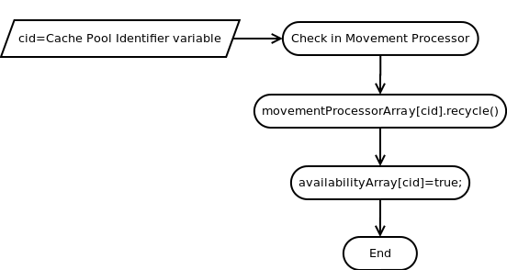
Movement Processor Pool: Check In operation: Flow Diagram: Dependencies:
- Sensor Processor is an interface that can Sensor Processor implementers implement their code to. Figure out how patent designers represent interfaces in code, or if they are simply specified as an Object type...

Movement Processor Pool: Check Out operation:
Checkout a Movement Processor by mid. mid is the Movement Processor Factory array index of the Movement Processor being requested.
It is up to the implementor of this Object in code to make sure that the RANGE_LENGTH is sufficient for the number of threads that may execute the RANGE. Additionally, the loop only cycles till the end of the array, and if the oldest checked out Object has not yet been returned to the pool, null is returned, therefore it is advised if null is returned that the implementing code retry checkout again. If the quantity of RANGE Objects is sufficient an Object wil always be available.

Java Source Code implementation:
public MovementProcessor checkout(int mid)
{
// maximum range index = (mid * RANGE_LENGTH) + RANGE_LENGTH - 1;
this.maximumIndexRangePlusOne = (mid * RANGE_LENGTH) + RANGE_LENGTH;
// Set the current checkoutCount to the mid range last checked out.
// checkoutCount = (mid * RANGE_LENGTH) + poolIterationCountArray[mid];
// subtraction is less math then multiplication, so subtract RANGE_LENGTH from maximumIndexRangePlusOne
this.checkoutCount = (maximumIndexRangePlusOne - RANGE_LENGTH) + poolIterationCountArray[mid];
if(checkoutCount<maximumIndexRangePlusOne)
{
// While loop must test range length to ensure an infinite loop does not occur.
while(checkoutCount<maximumIndexRangePlusOne)
{
// If value is false, check out Object, and set value to true.
if(this.availabilityArray[checkoutCount])
{
this.availabilityArray[checkoutCount]=false;
// Set the next checkout range position.
this.poolIterationCountArray[mid]=(this.checkoutCount - (maximumIndexRangePlusOne - RANGE_LENGTH)) + 1;
return (MovementProcessor)movementProcessorArray[checkoutCount];
}
this.checkoutCount = checkoutCount + 1;
}
return null;
}
else
{
// Reset poolIterationCountArray
poolIterationCountArray[mid]=0;
// Reset checkoutCount to 0 because it is out of index bounds.
this.checkoutCount = maximumIndexRangePlusOne - RANGE_LENGTH;
// While loop must test range length to ensure an infinite loop does not occur.
while(checkoutCount<maximumIndexRangePlusOne)
{
// If value is false, check out Object, and set value to true.
if(this.availabilityArray[checkoutCount])
{
this.availabilityArray[checkoutCount]=false;
// Set the next checkout range position.
this.poolIterationCountArray[mid]=(this.checkoutCount - (maximumIndexRangePlusOne - RANGE_LENGTH)) + 1;
return (MovementProcessor)movementProcessorArray[checkoutCount];
}
this.checkoutCount = checkoutCount + 1;
}
return null;
}
}

Movement Processor Pool: Check Out operation: Flow Diagram:

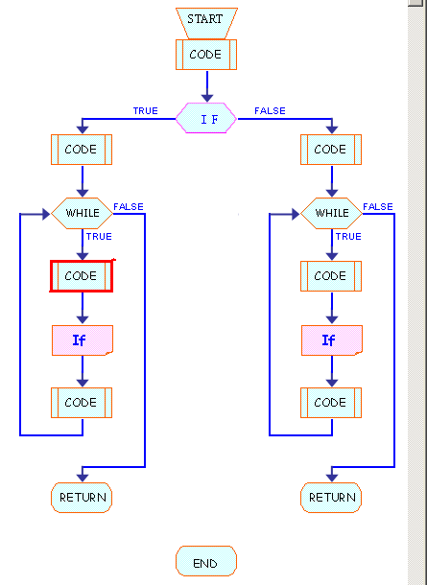

Movement Processor Pool: Check In operation: Flow Diagram: Dependencies:

Hardware IDs are associated with each RCSM incoming and outgoing connection between the robot, and

SensorProcessorManagerImpl – Controller.getInstructionManager().getProviderByName(“instruction_manager”).((InstructionDefinition) InstructionProviderInterface.getInstructionDefinition(hid or name)).getInstructionObject();
Controller.getInstructionManager().getProviderByName(“instruction_manager”).((InstructionDefinition) InstructionProviderInterface.getInstructionDefinition(hid or name)).getInstructionInputHandler();

// TODO: Fix the Byte[] OutputHandler Size algorithm, Fix the message definition nested Object source code generators for input and output handler, to have nested Object definitions included in the Maps, currently cannot be found... , and add variables for types in class scope, determine if defining ros_msg in method is faster than declaring it globally.

